**1. ReactJS-HOL**

**App.js:**

import React from 'react';

function App() {

  return (

    <div>

      <h1>Welcome to the first session of React</h1>

    </div>

  );

}

export default App;

**OUTPUT:**

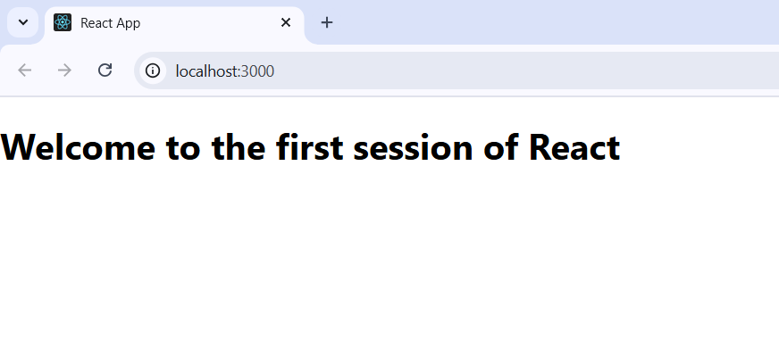

**2. ReactJS-HOL**

**App.js:**

import React from 'react';

import Home from './Components/Home';

import About from './Components/About';

import Contact from './Components/Contact';

import './App.css';

function App() {

  return (

    <div>

      <Home />

      <About />

      <Contact />

    </div>

  );

}

export default App;

**About.js:**

import React, { Component } from 'react';

class About extends Component {

  render() {

    return (

      <div>

        <h2>Welcome to the About page of the Student Management Portal</h2>

      </div>

    );

  }

}

export default About;

**Home.js:**

import React, { Component } from 'react';

class Home extends Component {

  render() {

    return (

      <div>

        <h2>Welcome to the Home page of Student Management Portal</h2>

      </div>

    );

  }

}

export default Home;

**Contact.js:**

import React, { Component } from 'react';

class Contact extends Component {

  render() {

    return (

      <div>

        <h2>Welcome to the Contact page of the Student Management Portal</h2>

      </div>

    );

  }

}

export default Contact;

**OUTPUT:**

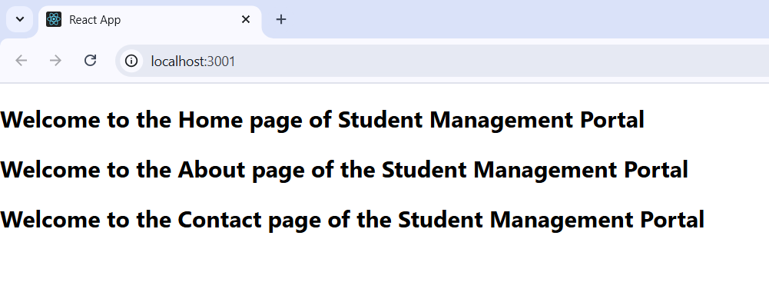

**3. ReactJS-HOL**

**CalculateScore.js:**

import '../Stylesheets/mystyle.css'

const percentToDecimal=(decimal)=>{

return (decimal.toFixed(2)+'%')

}

const calcScore=(total,goal)=>{

    return percentToDecimal(total/goal)

}

export const CalculateScore=({Name,School,total,goal})=>(

    <div className='formstyle'>

        <h1><font color='Brown'>Student Details:</font></h1>

        <div className='Name'>

            <b><span>Name:</span></b>

            <span>{Name}</span>

        </div>

         <div className='School'>

            <b><span>School:</span></b>

            <span>{School}</span>

        </div>

         <div className='Total'>

            <b><span>Total:</span></b>

            <span>{total}</span>

            <span>Marks</span>

        </div>

         <div className='Score'>

            <b>Score:</b>

            <span>{calcScore(total,goal)}</span>

        </div>

    </div>

)

.Name{

    font-weight: 300;

    color: blue;

}

.School{

    color: crimson;

}

.Total{

    color: darkmagenta;

}

.formstyle{

    text-align: center;

    font-size: large;

}

.Score{

    color: forestgreen;

}

**App.js:**

import { CalculateScore } from "./Components/CalculateScore";

function App(){

  return(

    <div>

      <CalculateScore Name={"Steeve"}

      School={"DNV Public School"}

      total={284}

      goal={3}

      />

    </div>

  )

}

export default App;

**OUTPUT:**

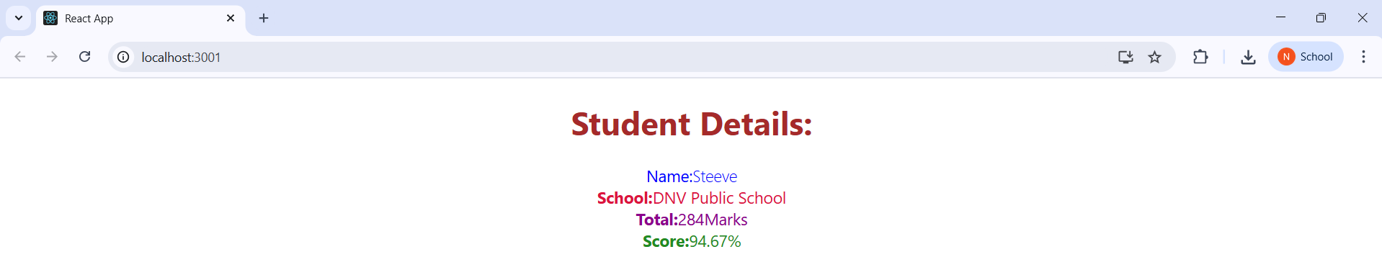

**4. ReactJS-HOL**

**App.js:**

import React from 'react';

import Posts from './Posts';

function App() {

  return (

    <div className="App">

      <Posts />

    </div>

  );

}

export default App;

**Post.js:**

class Post{

    constructor(id,title,body){

        this.id=id;

        this.title=title;

        this.body=body;

    }

}export default Post;

**Posts.js:**

import React from 'react';

import Post from './Post';

class Posts extends React.Component {

  constructor(props) {

    super(props);

    this.state = {

      posts: [],

    };

  }

  loadPosts = () => {

    fetch('https://jsonplaceholder.typicode.com/posts')

      .then((response) => response.json())

      .then((data) => {

        const postsList = data.map(

          (item) => new Post(item.id, item.title, item.body)

        );

        this.setState({ posts: postsList });

      })

      .catch((error) => {

        console.error('Error fetching posts:', error);

        alert('Failed to load posts');

      });

  };

  componentDidMount() {

    this.loadPosts();

  }

  render() {

    return (

      <div>

        <h1>All Posts</h1>

        {this.state.posts.map((post) => (

          <div key={post.id}>

            <h2>{post.title}</h2>

            <p>{post.body}</p>

            <hr />

          </div>

        ))}

      </div>

    );

  }

  componentDidCatch(error, info) {

    console.error('Error occurred:', error);

    alert('An error occurred in the Posts component.');

  }

}

export default Posts;

**OUTPUT:**

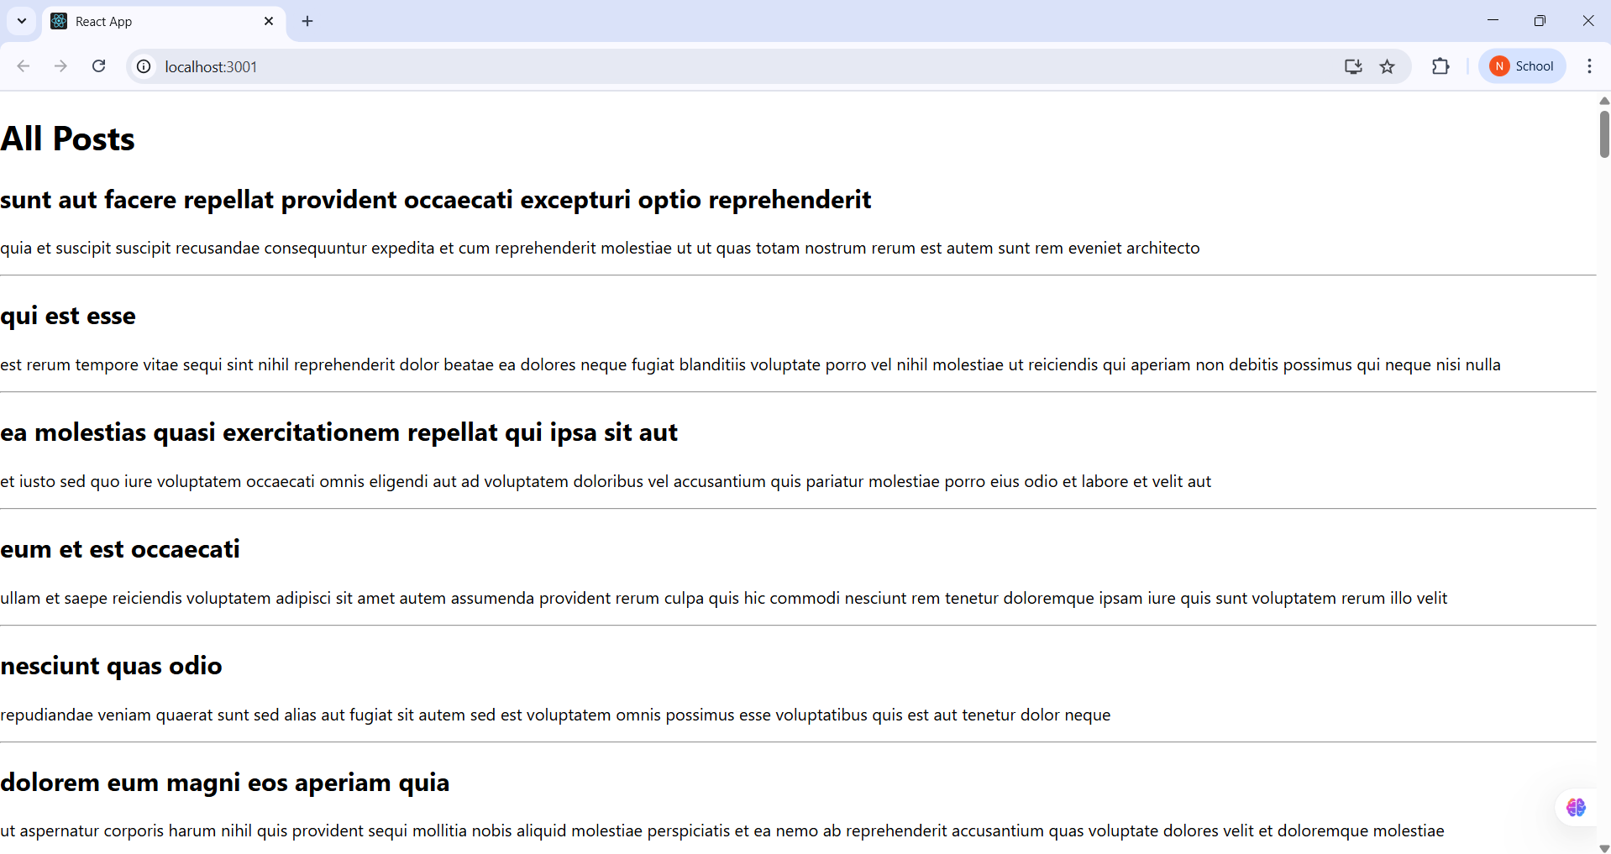

**5. ReactJS-HOL**

**App.js:**

import './App.css';

import { CohortsData } from './Cohort';

import CohortDetails from './CohortDetails';

function App() {

  return (

    <div style={{ border: '1px solid black', padding: '20px' }}>

      <h1>Cohorts Details</h1>

      <div style={{ display: 'flex', flexWrap: 'wrap', gap: '20px' }}>

        {CohortsData.map((cohort, index) => (

          <CohortDetails key={index} cohort={cohort} />

        ))}

      </div>

    </div>

  );

}

export default App;

**CohortDetails.js:**  
import styles from './CohortDetails.module.css';

function CohortDetails(props) {

    const status = props.cohort.currentStatus.toLowerCase();

    const statusColor = status === 'ongoing' ? 'green' : 'blue';

    return (

        <div className={styles.box}>

            <h3 style={{ color: statusColor }}>

                {props.cohort.cohortCode} -

                <span>{props.cohort.technology}</span>

            </h3>

            <dl>

                <dt>Started On</dt>

                <dd>{props.cohort.startDate}</dd>

                <dt>Current Status</dt>

                <dd>{props.cohort.currentStatus}</dd>

                <dt>Coach</dt>

                <dd>{props.cohort.coachName}</dd>

                <dt>Trainer</dt>

                <dd>{props.cohort.trainerName}</dd>

            </dl>

        </div>

    );

}

export default CohortDetails;

**CohortDetails.module.css:**

.box {

  width: 300px;

  display: inline-block;

  margin: 10px;

  padding: 10px 20px;

  border: 1px solid black;

  border-radius: 10px;

}

dt {

  font-weight: 500;

}

**OUTPUT:**

